Software Requirements Specification Document5

(SRS)

Team Members:-

Gaurav Vetal – 22138

Sandeep Verma – 22106

Biswanath Mandal – 22137

Dipashri Kokate – 22163

Shreeyashi Surwase – 22263

1.1-Purpose

Clubs and organizations are a big part of college life! A club is “a group of students organized with a similar interest for a social, literary, athletic, political, or other common purpose; while an organization is a group of students organized for and acting toward a particular cause ” . Students have the opportunity and choose to join these groups for many reasons including: pursuit of individual interests; career networking opportunities; social camaraderie; and political activities. Most colleges and universities have a very active student club and organizational system that can be accessed by visiting on-campus offices and individual websites. All students should be strongly encouraged to pursue club and organizational membership opportunities to help them enrich their college experience.

1.2-Document Conventions

There are no standard document requirements for this document.

1.3 Intended Audience and Reading Suggestions

Primary readers of this document are the web designers contributing to and testing of the club community portal . Contributors to this document are members of the Computer Science Branch. The remaining sections of this SRS describe the functional requirements for club community portal.

1.4 Project Scope

This project is based on the club community where this application gives maximum services in a single software product that is used by teacher and system administration. This project is based on a desktop application that is sharing information on different departments in a college.In this project that includes wordpress and SQL. wordpress is used to design the website by which the user can interact with software applications. The SQL Server is used for creating the database in which different information will store. The main focus of this project is to give the best software for the users and provide the many modules in a single product. .Every organization looks forward to mapping the customer journey and increase profitability through each customer and on the whole.

The objective is that each and every person can interact with each other without even knowing them .They can create their profile and (add their personal social media accounts) & post their doubts, articles , questions .They can be added in the clubs available in that specific place or field.

1.5 Reference

www.google.com

[www.youtube.com](http://www.youtube.com)

[www.letsupgrade.com](http://www.letsupgrade.com)

1.6 Overview

This software requirement document is prepared according to IEEE Std. 830-1998 and it is divided into sections and practices. User classes are used, while organizing functional requirements, which is recommended in template of SRS section in standard document.

This document starts with explanation of the project. It continues with the overview of the project and describes the general factors that can affect the system requirements. On the requirements specification chapter, system requirements will be explained in detail with the technical terms. It is explained for the developers mainly. On this process, use case diagrams , mock interfaces and er diagrams will be used.

2. Overall Description

This sections main focus is to show the main factors which affects the product and its requirements in detail. This section also contains information about features and why it is selected. In some sections there are some attributes which enable the product to be able to evolve in the future.

2.1 Product Perspective

Club community portal is an example of an education community web portal is a large state university managing an online community to monitor everything including admissions, grievances, curriculum, and placement.

2.2 Product Features

• Each and every person can interact with each other without even knowing them .

• They can create their profile

• They can post their doubts &questions

• They can post article

2.3. User characteristics

There will be no required specific characteristic to use this website. the expected skill is to know how to use website .Students can easily interact with people and post their doubts and questions in group.

3. System Features

3.1 Functional Requirements

3.1.1 Log in Module (LM)User (admin, student and teachers) shall be able to load the Login Module in the internet browser. The LM shall support the user to log into the system. The login panel shall contain fields to contain a user name and a field for password. The password field shall be masked with symbols when the user types. It shall also contain a button labelled as Login. When the user clicks on Login button the username and password will be verified by database administrator and then only the user will able to use the system functions.

3.1.2 Registered Users Module (RUM)After successful login, user shall be able to continue navigating through the website and view school/college detailed information. After successful login, user (admin, student and teachers) shall be able to update and maintain their profile, such as changing password and personal details

3.1.3 Normal Users Module (NUM)Users who visit SMS but have not registered, are able to navigate through the website. Users shall be able to view currently held events & upcoming institute schedule. Users shall be able to view school/college timings and their faculties information. Users are able to register themselves as registered users, by clicking on the register now button.

3.1.4 Administrator Module (AM)After successful login, system shall display administrative functions. Administrative functions shown shall be add and update. When administrator clicks on the add button, system shall display a section where administrator can add new student details, remove unused student details and many more. When administrator clicks on update button, system shall display a section where administrator can update student details and schedule of lecture which are currently stored in the database. When administrator adds, updates or delete and entry, the AM module will send the request to the Server Module which will do the necessary changes to the DB.

3.1.5 Server Module (SM)SM shall be between the various modules and the DB. SM shall receive all requests and format the pages accordingly to be displayed. SM shall validate and execute all requests from the other modules.

4. External Interface Requirements

4.1.1 User Interfaces - The student club community portal system must provide a user interface that will be accessible through any internet browser, the major ones being Google Chrome and Internet Explorer 12.

4.1.2 Hardware Interfaces - All components able to be executed on personal computers with Windows OS platforms and other platforms like Linux, Unix.

4.1.3 Software Interfaces - All the interfaces will be ASPX pages running within the internet browser. The SMS must integrate with the DB though SQL Interface. The system will be hosted in a web server running on Windows Server 2005.

4.1.4 Communications Interfaces Connections to the system will be over TCP/IP connection.

4.2 USER INTERFACES

Front-end software: Word press

Back-end software: SQL

4.3 HARDWARE INTERFACES

Club Community portal is a website which will need windows and a browser which supports word press.

All components able to be executed on personal computers with Windows OS platforms and other platforms like Linux.

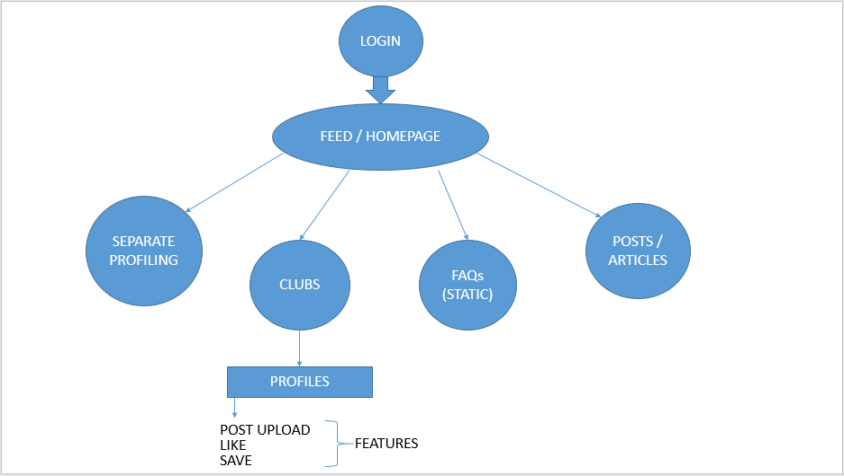

4.4 Communication Interfaces

Each and every person can interact with each other without even knowing them

Club community Portal will use the available wifi to communicate with the server.

Club community portal will use the available cellular internet connection to communicate with the server.

5 Non-functional Requirements

Non-functional requirements may exist for the following attributes. Often these requirements must be achieved at a system wide level rather than at a unit level. State the requirements in the following sections in measurable terms.

5.5.1 Performance - The Student Club Community Portal shall be built upon the web development technique and put on the web server online. The system and the server must be capable of handling the real- time error functionality occurs by the defined users. In addition, the system must be safety critical. All failures reported by the server side must be handled instantaneously to allow for user and system safety.

5.5.2 Reliability - The system is safety critical. If it moves out of normal operation mode, the requirement to drop or down the server and fix it as soon as possible and open it again. This emergency behaviour shall not occur without reason.

5.5.3 Availability - When in normal operating conditions, request by a user for an online system shall be handled within 1 second. Immediate feedback of the systems activities shall be communicated to the user by clearing the system and giving space n speed to their hospitality.

5.5.4 Security - There shall be a strong security mechanism should be place in the server side of the system to keep unwanted users to hack or damage the system. However, all users of the system give and store the details of privacy related to personal information and many other. However, our system can be accessed online so we need very secured system as far as security is concerned.

5.5.5 Maintainability - There shall be design documents describing maintenance of the software and database used to save the user details as well as the daily updated and modification done in system. There shall be an access on the control system by the admin to maintained it properly at the front end as well as at back end.

5.5.6 Portability - There is portability requirement as far as our system is concern because it is an online as well as offline (local server based) system so we can access it from anywhere through the internet connection. And we have to maintain the copy of stored data into our database.

**6 Conclusion**

Several groups can also be formed on certain topics to get updates related to it. These groups play a major role in highlighting the issues caused by an individual or a group of colleges. This makes this social networking platform an amazing one for the students as they can get connected and can share important information.